Questions & Problems:
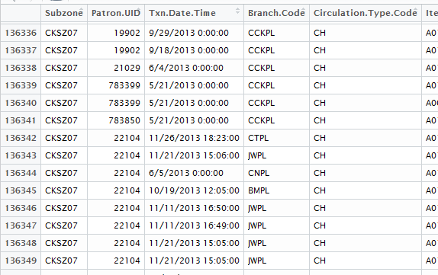
1. "CKSZ07" is not a valid subzone code from the "Master Plan 2014 Subzone Boundary (Web)" shape file extracted from data.gov.sg. So, the corresponding transaction records should be double-checked and verified with NLB.
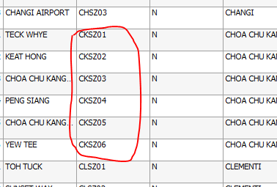
2. For the subzones with population = 0 in year 2013 (data extracted from Statistics Singapore), there are, however, frequency more than 0, meaning there are people from those subzones visiting libraries, which doesn't make sense (e.g. subzone CHSZ03)
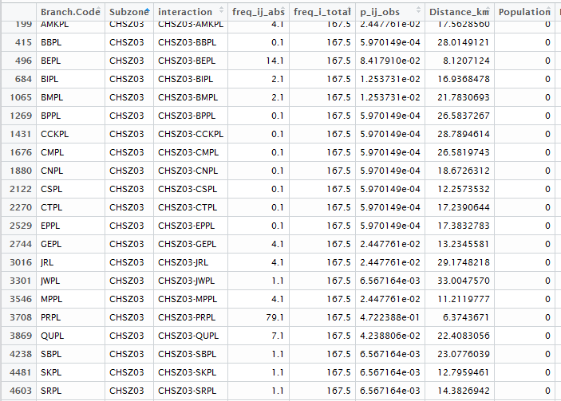
3. mci.transmat function generates zero/negative values for all numerical variables (excluding dummy ones), and the purpose of this step is unclear because the transformed output data frame "ijmatrix_TXN13_transf" is never used in any further step and yet, the variables in mci summary all have the "_t" in their names indicating they are after-transformation (?)
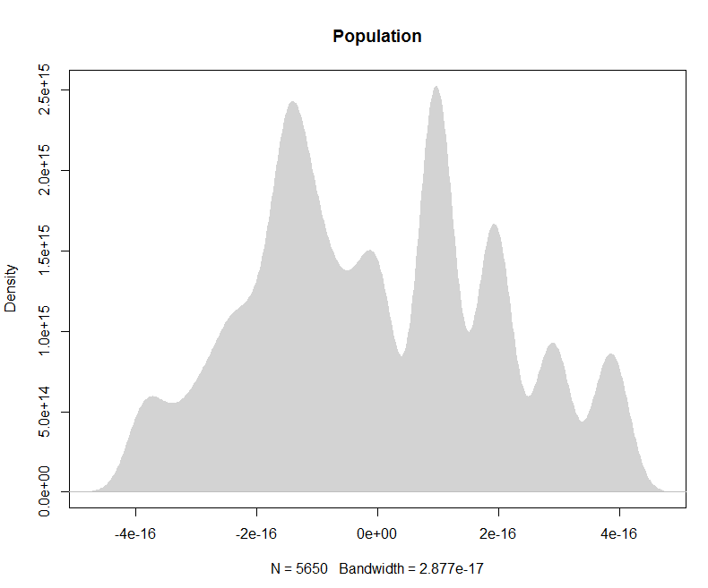
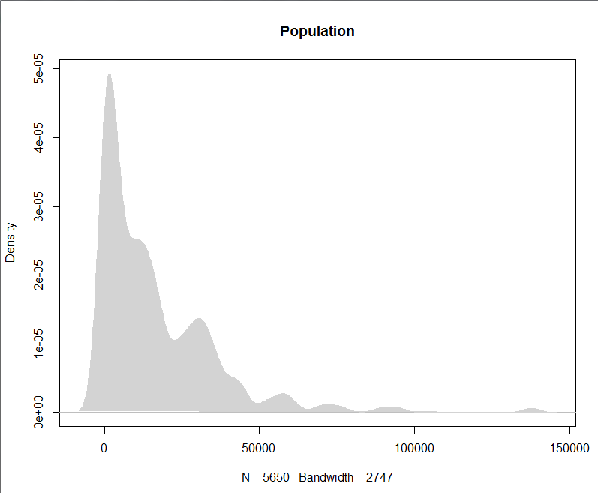
Before transformation After transformation
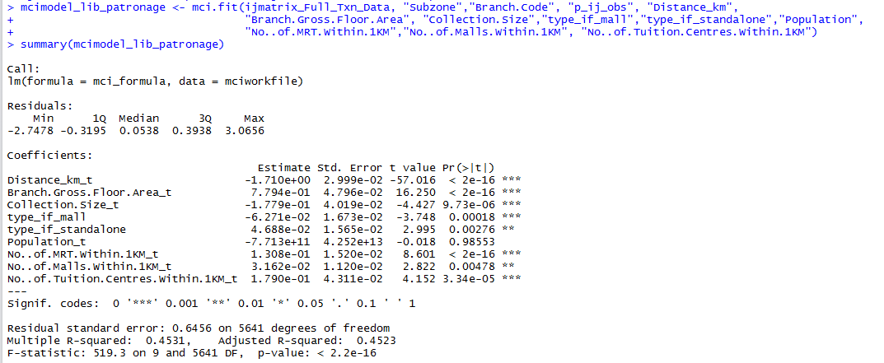
Summary of MCI output
4. In the huff.fit function, the "lambda" represents a single numeric value for the (exponential) weighting of distance (transport costs0, so shall we replace the default -2 with the weightage of Distance_km we got from MCI summary -1.71?
5. Due to the existing of negative value in variable "predicated_value", huff.fit function runs with error immediately. (NA does not exist in the whole data frame)
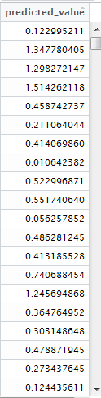
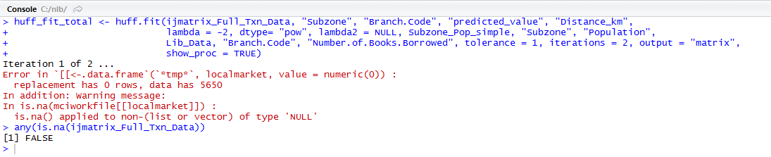
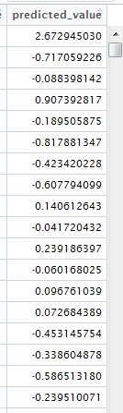
6. Even all columns contain only positive value s, huff.fit still cannot run successfully.
Problem 6:
Predicated_value doesn’t contain negative value

Problem 5:
Predicated_value contains negative value

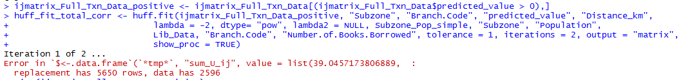
Huff error from Problem 5 (when predicted_value contains negative value
Huff error from Problem 6 (when no more negative value exists in the data)

